**C PLUS PLUS - CONVERTNUMBER**

**-Binary to Decimal**

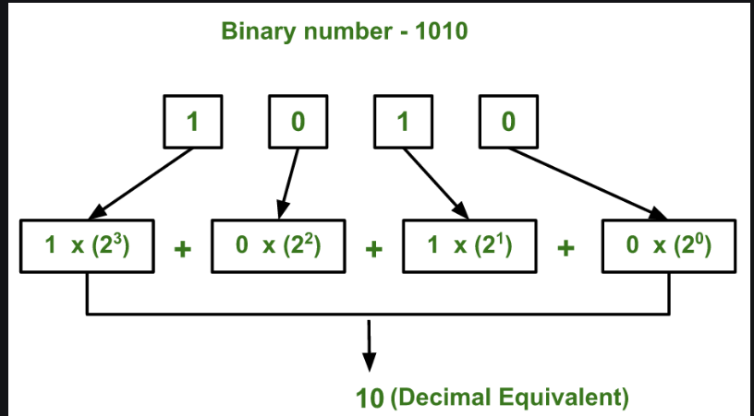

**-Sources code**

**-Decimal to Binary**

**-Sources code**

**-Octal to Decimal**

**-Sources code**

**-Decimal to Octal**

**-Sources code**

**-Binary to Octal**

**-Sources code**

**-Octal to binary**

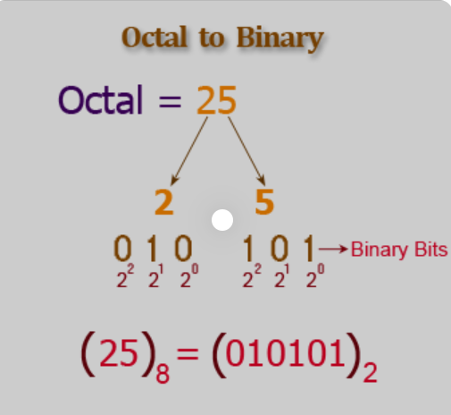

**-Sources code**

